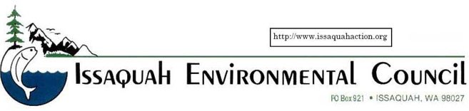

September 17, 2018

Dear DeLeo Wall Supporters;

We are very concerned with the Department of Natural Resources (DNR) approved application to log 35 acres contiguous on two sides to Cougar Mountain Regional Wildland Park. These parcels contain the DeLeo Wall, a regional landmark, and a unique geological feature on the south side of Cougar Mountain. Clear cutting would negatively effect the environment, wildlife and trails.

As areas like Issaquah see intense development it becomes ever more important to preserve our nearby second growth forested properties. In this case the De Leo Wall is heavily populated with critical areas and has rarely found vegetation like Garry Oak, Chocolate Lilies, Fawn Lilies and, importantly, Phantom Orchids. The steep slopes create erosion hazards if logged that are likely to impact May Creek, and corresponding wetlands and tributaries.

We commend “The Save De Leo Wall Campaign” facilitating a public-private partnership to purchase the property as permanent open space connecting with existing recreational trails and wildlife corridors.

If the property can be acquired impacts to trails, streams, habitat, wetlands, and riparian zones will be avoided. The hazards of erosion and runoff into May Creek and possible slash fires will be eliminated.

We are included in the broad and passionate public support for acquisition of the DeLeo Wall property as an adjunct to Cougar Mountain Regional Wildland Park.

Sincerely,

John MacDuff
President, Issaquah Environmental Council

